**Hybrid Offline Navigation button type**

**Installation**

1. Copy the “**com.temenos.widgets.hybrid.offlineNavigation”** folder in your widgets folder (Ex: /{your project/templates })
2. Copy the content of **widget.xml** in your widget.xml file within your project
3. In the Developer IDE, access **Tools -> Edit Widgets for Project,** click on the widget and make sure that the path indicated by “Source Template” matches the location of the file „hybridOfflineNavigation.wgt”.

**How to use**

1. You will have to add a new custom button in your presentation. Within **Appearance** -> **Button tab** for ”Display Type” field you have to select “Hybrid Offline Navigation “
2. Within Widget Details tab you have to set up the phase to navigate to if the device is offline. **Important:** make sure that the phase you select is an offline phase. Altough you can select any phase, it only makes sense to select an offline phase.

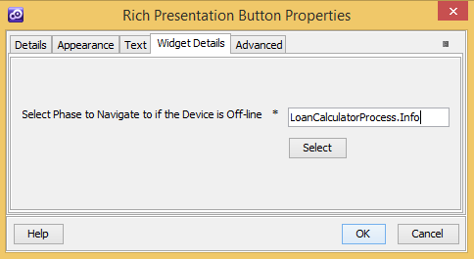

1. In process editor, the off-line navigation button behaves like a normal button, you can attach “go to” rules for going back online. Those rules will be invoked only if the device is connected to the internet, otherwise pressing the button will navigate to the offline phase defined above.